**CHAPTER 1**

**Introduction to Web**

An dynamic website is used for description of items and make it user friendly. Dynamicity of website has been growing rapidly around the world and it also gives boost to the economic growth. Today many dynamic websites are available which may displays a range of items or describe a product of a particular genre such as a website which describes medicines. A website may be static or dynamic. A static website comprises of only web pages containing text and multimedia whereas a dynamic website comprises of a front end and a back end. E-commerce website is an example of dynamic website. The front end comprises of the matter which is viewed by the user, such as text and multimedia. This is also known as client side. While the back end takes place at the server from which the website runs. This part is responsible for the dynamic functionality of the website such as management of database, user authentication etc. This is also known as server side because the processing takes place at the server end. For example when the user tries to log in to his/her account, the page that is viewed by the user which contains the form to fill up and submit button is the front end. While, the information entered by the user is sent to the server for processing. The server authenticates and validates the information entered by the user. The information is matched with the data present in the database which is managed by database management software. If the user has entered correct information, he/she gets a mail from the company that states the company will contact them soon and reply to the query. If the information entered by the user is incorrect, the server denies the access. This is known as back end or the server end. For this functionality to take place, we have to program the server as well. Various scripting languages are available for designing the back end part such as JavaScript, PHP etc. In this project, we are using PHP which is a scripting language. Programming the front end is known as client side scripting, while programming the back end is known as server side scripting. For the front end part, HTML (Hypertext Mark-up Language), provides a basic framework to our webpage. While CSS (Cascading Style Sheet) provides it visual polish. Many frameworks are available to further beautify our website, such as Bootstrap. Bootstrap is a framework for the front end design of the website. It contains HTML and CSS-based design templates for typography, forms, buttons, navi

**Introduction to HTML**

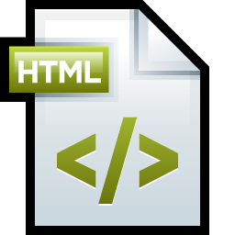 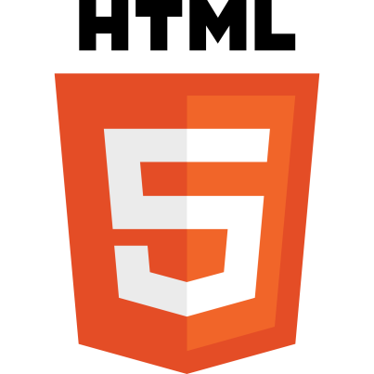

HTML stands for Hypertext Markup Language, and it is the language in which, until recently, virtually all Web pages were written. Now, don’t break out in hives when you hear the word “language.” You don’t need complex logical or mathematical formulas to work with HTML, and you don’t need to think like a programmer to use it. Computer programmers must think through the tasks that they want their programs to perform, and then develop an elaborate (and usually complicated) series of instructions to tell the computer what to do. Although you do need to do some thinking and planning when you use HTML, it is not nearly that difficult. So, how does Hypertext Markup Language work?

Hypertext refers to the way in which Web pages (HTML documents) are linked together. When you click a link in a Web page, you are using hypertext. It is this system of linking documents that has made the World Wide Web the global phenomenon it has become.

Markup Language describes how HTML works. With a markup language, you simply “mark up” a text document with tags that tell a Web browser how to structure it. HTML originally was developed with the intent of defining the structure of documents (headings, paragraphs, lists, and so forth) to facilitate the sharing of scientific information between researchers. All you need to do to use HTML is to learn what type of markup to use to get the results you want

Web browsers displaying an HTML page can be pretty forgiving if your elements are not properly nested; however, overlapped elements can create garbled results, particularly if you are trying to construct frames or tables. Also, when you become familiar with XHTML’s stricter standards, you’ll discover that overlapping elements are an absolute “no-no.”

HTML Version used in project

HTML5 is the latest version that is being used in present web development. It was introduced in 2014

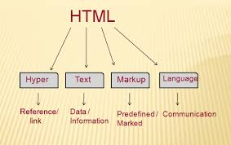

**Introduction to CSS**

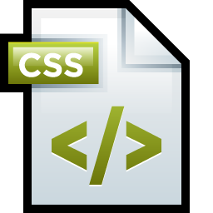

Cascading Style Sheets (CSS) is a style sheet language used for describing the presentation of a document written in a mark-up language. Although most often used to set the visual style of web pages and user interfaces written in HTML and XHTML, the language can be applied to any XML document, including plain XML, SVG and XUL, and is applicable to rendering in speech, or on other media. Along with HTML and JavaScript, CSS is a cornerstone technology used by most websites to create visually engaging web pages, user interfaces for web applications, and user interfaces for many mobile applications.

CSS is designed primarily to enable the separation of document content from document presentation, including aspects such as the layout, colours, and fonts. This separation can improve content accessibility, provide more flexibility and control in the specification of presentation characteristics, enable multiple HTML pages to share formatting by specifying the relevant CSS in a separate .css file, and reduce complexity and repetition in the structural content. This separation of formatting and content makes it possible to present the same mark-up page in different styles for different rendering methods, such as on-screen, in print, by voice (when read out by a speech-based browser or screen reader) and on Braille-based, tactile devices. It can also be used to display the web page differently depending on the screen size or device on which it is being viewed. Readers can also specify a different style sheet, such as a CSS file stored on their own computer, to override the one the author has specified.

Eg of an id selector:

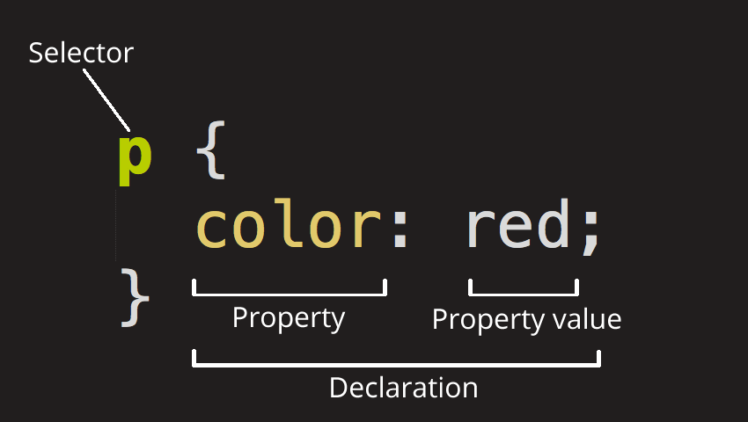

Changes to the graphic design of a document (or hundreds of documents) can be applied quickly and easily, by editing a few lines in the CSS file they use, rather than by changing mark-up in the documents.

The CSS specification describes a priority scheme to determine which style rules apply if more than one rule matches against a particular element. In this so-called cascade, priorities (or weights) are calculated and assigned to rules, so that the results are predictable.

**Introduction to Bootstrap**

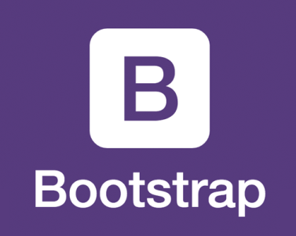 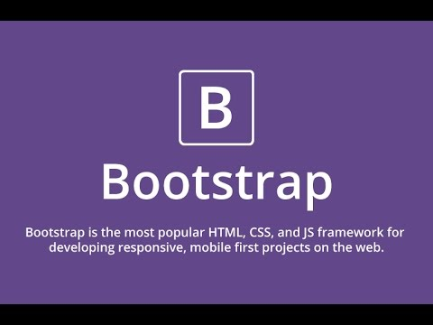

Bootstrap is a free and open-source front-end web framework for designing websites and web applications. It contains HTML- and CSS-based design templates for typography, forms, buttons, navigation and other interface components, as well as optional JavaScript extensions. Unlike many web frameworks, it concerns itself with front-end development only.

Bootstrap is the second most-starred project on Git Hub, with over 95 thousand stars and more than 40 thousand forks. Bootstrap is compatible with the latest versions of the Google Chrome, Firefox, Internet Explorer, Opera, and Safari browsers, although some of these browsers are not supported on all platforms. Since version 2.0 it also supports responsive web design. This means the layout of web pages adjusts dynamically, taking into account the characteristics of the device used (desktop, tablet, mobile phone). Starting with version 3.0, Bootstrap adopted a mobile-first design philosophy, emphasizing responsive design by default. The version 4.0 alpha release added Sass and Flexbox support. Bootstrap is open source and available on GitHub. Developers are encouraged to participate in the project and make their own contributions to the platform. Bootstrap is modular and consists essentially of a series of Less stylesheets that implement the various components of the toolkit. A stylesheet called bootstrap less includes the components stylesheets. Developers can adapt the Bootstrap file itself, selecting the components they wish to use in their project. Adjustments are possible to a limited extent through a central configuration stylesheet. More profound changes are possible by the Less declarations. The use of Less stylesheet language allows the use of variables, functions and operators, nested selectors, as well as so-called mixins.

Since version 2.0, the configuration of Bootstrap also has a special "Customize" option in the documentation. Moreover, the developer chooses on a form the desired components and adjusts, if necessary, the values of various options to their needs. The subsequently generated package already includes the pre-built CSS style sheet.

As of Bootstrap 4, Sass will be used for stylesheets instead of less. Grid system and responsive design comes standard with 1170 pixel wide, grid layout. Alternatively, the developer can use a variable-width layout. For both cases, the toolkit has four variations to make use of different resolutions and types of devices: mobile phones, portrait and landscape, tablets and PCs with low and high resolution. Each variation adjusts the width of the columns.

**Advantages of Bootstrap:**

* **Easy to use:** Anybody with just basic knowledge of HTML and CSS can start using Bootstrap
* **Responsive features:** Bootstrap's responsive CSS adjusts to phones, tablets, and desktops
* **Mobile-first approach:** In Bootstrap 3, mobile-first styles are part of the core framework
* **Browser compatibility:** Bootstrap is compatible with all modern browsers (Chrome, Firefox, Internet Explorer, Safari, and Opera)

**Introduction to Java-Script**

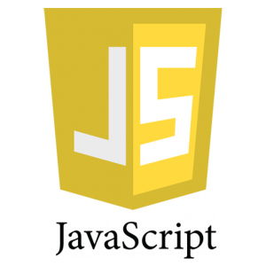

JavaScript is most commonly used as a client side scripting language. This means that JavaScript code is written into an HTML page. When a user requests an HTML page with JavaScript in it, the script is sent to the browser and it's up to the browser to do something with it.

JavaScript, the language, is

* Small and elegant
* Very expressive and powerful
* Mostly dynamic, with prototype-based, not class-based, object orientation
* [Misunderstood](http://www.crockford.com/javascript/javascript.html)
* Phenomenally popular
* Designed to be run inside a host context, like a web browser or server (e.g., [node.js](http://nodejs.org/))
* The power behind cool applications like Google Maps
* Built on the internationally standardized ECMAScript language (like its cousin, ActionScript)

JavaScript began as "Mocha," written by Brendan Eich in [10 days in May of 1995](http://www.quora.com/JavaScript/Did-Javascript-evolve-from-another-product-or-scripting-language/answer/Brendan-Eich). The name was changed to "LiveScript" in September, 1995, and became "JavaScript" sometime after that.

JavaScript is one of the 3 languages all web developers must learn:

   1. HTML to define the content of web pages

   2. CSS to specify the layout of web pages

   3. JavaScript to program the behavior of web page

**Advantages of JavaScript:**

* **Javascript is executed on the client side**  
  This means that the code is executed on the user's processor instead of the web server thus saving bandwidth and strain on the web server.
* **Javascript is a relatively easy language**  
  The Javascript language is relatively easy to learn and comprises of syntax that is close to English. It uses the DOM model that provides plenty of prewritten functionality to the various objects on pages making it a breeze to develop a script to solve a custom purpose.
* **Javascript is relatively fast to the end user**  
  As the code is executed on the user's computer, results and processing is completed almost instantly depending on the task (tasks in javascript on web pages are usually simple so as to prevent being a memory hog) as it does not need to be processed in the site's web server and sent back to the user consuming local as well as server bandwidth.

* **Extended functionality to web pages**  
  Third party add-ons like Greasemonkey enable Javascript developers to write snippets of Javascript which can execute on desired web pages to extend its functionality. If you use a website and require a certain feature to be included, you can write it yourself and use an add-on like Greasemonkey to implement it on the web page.

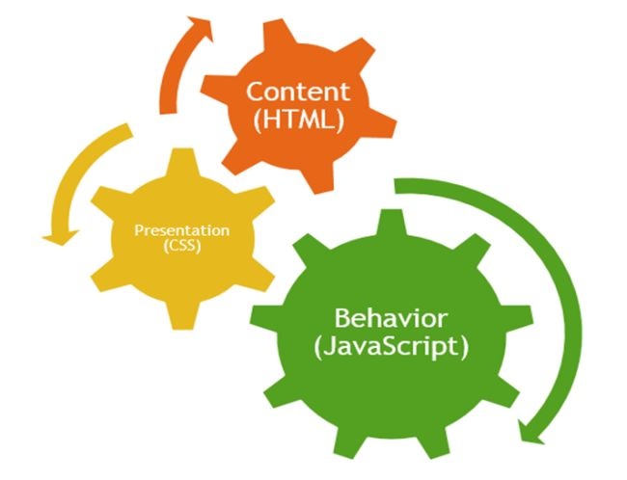

**Introduction to Jquery**

JQuery is a JavaScript library, so installing it is just a matter of importing a script inside a Web page. However, there are a few best practices to be aware of:

* JQuery is available through several content delivery networks (CDN). Using those CDNs instead of installing JQuery on your servers should provide significant performance and bandwidth gains.
* As with any static content, JQuery files should be served compressed. That's why there are two versions of JQuery available: a minified (or “min”) version, which is small and efficient, and a development version, which is easier to read and debug. For the rest of this article, we will use the min version, which is enough for our needs.
* JQuery files should be cached on the client side, so you should use the JQuery version number in the file name.

## Selecting Elements with JQuery

The easiest way to get started with JQuery is to select some elements on our sample Web page.

Let's select the author division, which we copied and pasted in the previous section, in order to change this element to display some user information. As you can see from the HTML code and the CSS file, it currently contains the user ID, and it is included in a hidden <div> element. There are several ways to select this HTML element. Let's start by using its ID:

$("#author");

$ is not a JavaScript-specific keyword. It's a one-letter function that is defined by JQuery. The text that is passed to this function is parsed by JQuery, which then generates the correct series of JavaScript functions to select the requested Document Object Model (DOM) elements. This method of selecting DOM elements is concise and browser-independent, which addresses the two most important problems that arise with JavaScript programming. As a result, JQuery enables quick, simple, and powerful cross-browser selection of DOM nodes in the Web page.

Of course, the ID is not the only way to select elements. You can use the elements' class or some properties of those elements. For example, you can select all the elements with the vote class:

**Advantages of Jquery:**

JQuery has been a blessing for several web developers, experienced and newbie alike. It is a library for Javascript that immensely simplifies programming with javascript providing very easy to use, condensed syntax to achieve even apparently complex tasks with Javascript. The use of JQuery has several benefits over using other javascript libraries or the raw javascript itself.

* **Ease of use**  
  This is pretty much the main advantage of using JQuery, it is a lot more easy to use compared to standard javascript and other javascript libraries. Apart from simple syntax, it also requires much less lines of code to achieve the same feature in comparison.
* **Large library**  
  JQuery enables you to perform hordes of functions in comparison to other Javascript libraries.
* **Strong opensource community. (Several jQuery plugins available)**  
  JQuery, while relatively new, has a following that religiously devote their time to develop and enhance the functionality of JQuery. Thus there are hundreds of prewritten plugins available for download to instantly speed up your development process. Another advantage behind this is the efficiency and security of the script.
* **Great documentation and tutorials**  
  The JQuery website has a comprehensive documentation and tutorials to get even an absolute beginner in programming to get the ball rolling with this library.
* **Ajax support**  
  JQuery lets you develop Ajax templates with ease, Ajax enables a sleeker interface where actions can be performed on pages without requiring the entire page to be reloaded.

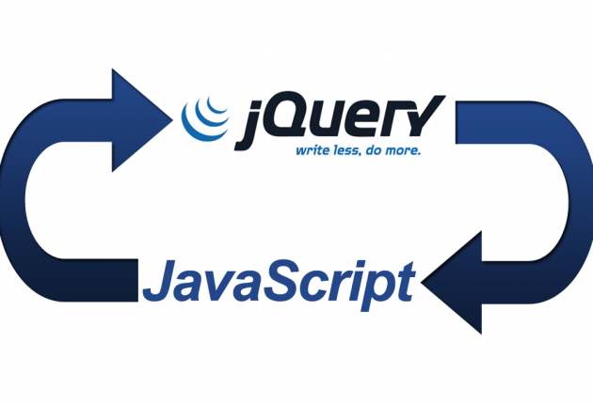

**Introduction to PHP**

PHP is a server-side scripting language designed for web development but also used as a general-purpose programming language. Originally created by Rasmus Lerdorf in 1994, the PHP reference implementation is now produced by The PHP Group.[5] PHP originally stood for Personal Home Page, but it now stands for the recursive acronym PHP: Hypertext Preprocessor.

PHP code may be embedded into HTML code, or it can be used in combination with various web template systems, web content management systems and web frameworks. PHP code is usually processed by a PHP interpreter implemented as a module in the web server or as a Common Gateway Interface (CGI) executable. The web server combines the results of the interpreted and executed PHP code, which may be any type of data, including images, with the generated web page. PHP code may also be executed with a command-line interface (CLI) and can be used to implement standalone graphical applications.

The standard PHP interpreter, powered by the Zend Engine, is free software released under the PHP License. PHP has been widely ported and can be deployed on most web servers on almost every operating system and platform, free of charge.

The PHP language evolved without a written formal specification or standard until 2014, leaving the canonical PHP interpreter as a de facto standard. Since 2014 work has gone on to create a formal PHP specification.

During the 2010s there have been increased efforts towards standardisation and code sharing in PHP applications by projects such as PHP-FIG in the form of PSR-initiatives as well as Composer dependency manager and the Packagist repository.

**What Can PHP Do?**

* PHP can generate dynamic page content
* PHP can create, open, read, write, delete, and close files on the server
* PHP can collect form data
* PHP can send and receive cookies
* PHP can add, delete, modify data in your database
* PHP can be used to control user-access
* PHP can encrypt data

With PHP you are not limited to output HTML. You can output images, PDF files, and even flash movies. You can also output any text, such as XHTML and XML.

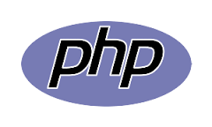

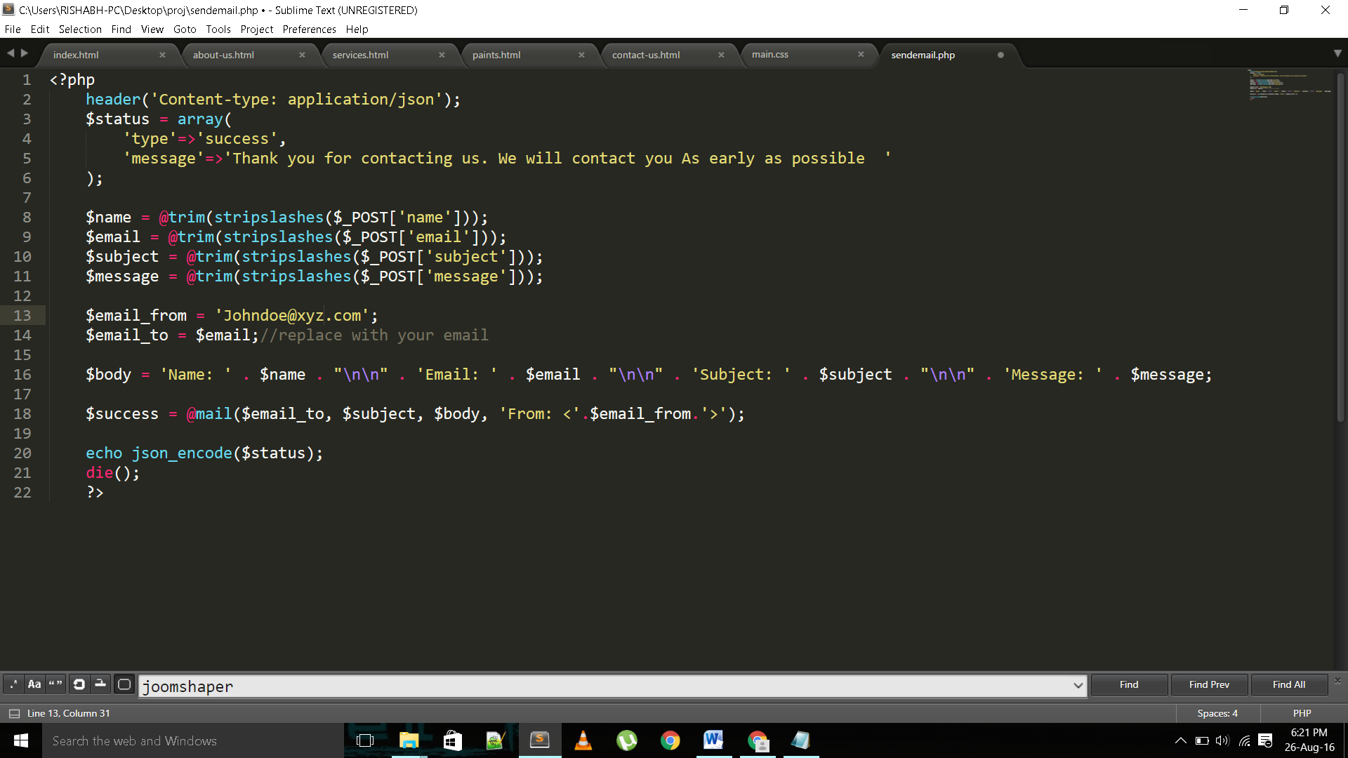

**Advantages of Php:**

PHP web development means developing websites and dynamic web pages using the versatile and capable server-side scripting language, PHP. It offers a plethora of benefits. Not only is it open-source but also feature-rich and has all the functionality that a proprietary or paid scripting language would offer. Here are a few benefits that have made PHP web development so sought after.

1. FREE OF COST: PHP is open source and is developed and updated by a community of developers from around the globe. Therefore, all its components are free to use and distribute.

2 . CAPABLE: It can be used to design any type of website and can handle websites with a lot of traffic. Facebook, Twitter, Wikipedia and many other very widely visited websites use it as their framework. And because it is server-side scripting, it can do anything that other CGI programs can do.

3. EASY: It has a readable and easily understandable syntax. Its code is embedded in the HTML source code and it is based on C/C++. Therefore, it is very familiar and programmers are very comfortable coding with it.

4. PLATFORM INDEPENDENT: It can be run on all major operating systems like Linux, UNIX, Mac OS and Windows.

5. SUPPORTS ALL MAJOR WEB SERVERS

It supports all major web servers like Apache, Microsoft IIS, Netscape, personal webserver, iPlanet server, etc.

6 – SUPPORTS ALL MAJOR DATABASES

IT supports all major databases including MySQL, dBase, IBM DB2, InterBase, FrontBase, ODBC, PostgreSQL, SQLite, etc.

**Front End framework**

The website extensively uses HTML, CSS and Bootstrap for its front end part. HTML provides basic framework or structure to the web-pages while CSS and Bootstrap are used to give it a more attractive and user friendly polish. CSS scripts are both inline and embedded, while bootstrap is downloaded from CDN. CDN stands for Content Delivery Network. Since Bootstrap is a collection of many prewritten HTML and JavaScript codes, it requires some files to be downloaded to our system and then it is available for use. However, if we wish not to download any file, we can simple tell HTML to get bootstrap by CDN online through the following code in the <head> part of the HTML document.

<link rel="stylesheet" href="https://maxcdn.bootstrapcdn.com/bootstrap/3.3.7/css/bootstrap.min.css" integrity="sha384-BVYiiSIFeK1dGmJRAkycuHAHRg32OmUcww7on3RYdg4Va+PmSTsz/K68vbdEjh4u" crossorigin="anonymous">

<link rel="stylesheet" href="https://maxcdn.bootstrapcdn.com/bootstrap/3.3.7/css/bootstrap-theme.min.css" integrity="sha384-rHyoN1iRsVXV4nD0JutlnGaslCJuC7uwjduW9SVrLvRYooPp2bWYgmgJQIXwl/Sp" crossorigin="anonymous">

<script src="https://maxcdn.bootstrapcdn.com/bootstrap/3.3.7/js/bootstrap.min.js" integrity="sha384-Tc5IQib027qvyjSMfHjOMaLkfuWVxZxUPnCJA7l2mCWNIpG9mGCD8wGNIcPD7Txa" crossorigin="anonymous">

</script>

There are many other ways to install bootstrap directly into our system, if we do not wish to include bootstrap through CDN. However, in this project, Bootstrap through CDN is used in every standalone page.

**Introduction to Adobe Photoshop(CS 6)**

Adobe Photoshop is a raster graphics editor developed and published by Adobe Systems for Mac OS and Windows.

Photoshop was created in 1988 by Thomas and John Knoll. Since then, it has become the de facto industry standard in raster graphics editing, such that the word "photoshop" has become a verb as in "to Photoshop an image," "photoshopping" and "photoshop contest", though Adobe discourages such use. It can edit and compose raster images in multiple layers and supports masks, alpha compositing and several color models including RGB, CMYK, Lab color space, spot color and duotone. Photoshop has vast support for graphic file formats but also uses its own PSD and PSB file formats which support all the aforementioned features. In addition to raster graphics, it has limited abilities to edit or render text, vector graphics (especially through clipping path), 3D graphics and video. Photoshop's featureset can be expanded by Photoshop plug-ins, programs developed and distributed independently of Photoshop that can run inside it and offer new or enhanced features.

Photoshop's naming scheme was initially based on version numbers. However, in October 2002, following the introduction of Creative Suite branding, each new version of Photoshop was designated with "CS" plus a number; e.g., the eighth major version of Photoshop was Photoshop CS and the ninth major version was Photoshop CS2. Photoshop CS3 through CS6 were also distributed in two different editions: Standard and Extended. In June 2013, with the introduction of Creative Cloud branding, Photoshop's licensing scheme was changed to that of software as a service rental model and the "CS" suffixes were replaced with "CC". Historically, Photoshop was bundled with additional software such as Adobe ImageReady, Adobe Fireworks, Adobe Bridge, Adobe Device Central and Adobe Camera RAW.

Alongside Photoshop, Adobe also develops and publishes Photoshop Elements, Photoshop Lightroom, Photoshop Express and Photoshop Touch. Collectively, they are branded as "The Adobe Photoshop Family". It is currently a licensed software.

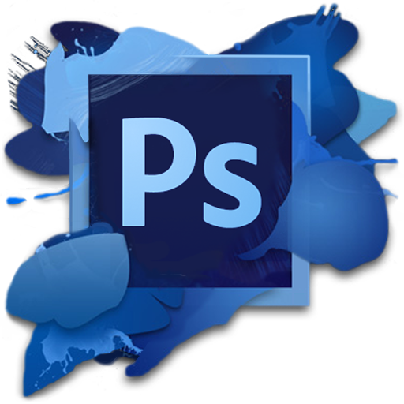

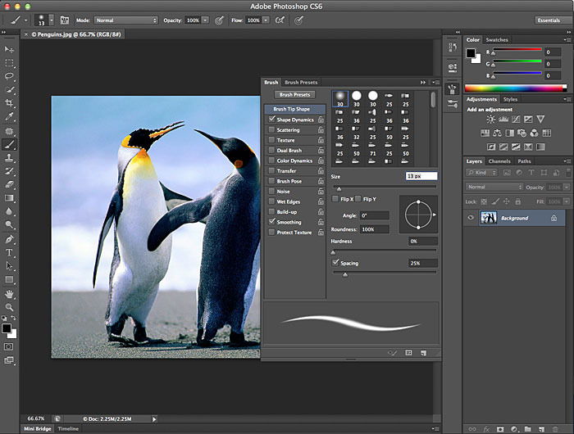

**CHAPTER 2**

**Libraries and API’s**

**Introduction**

Whenever the mainstream business media starts to cover a technology as though it is some sort of wonder drug (like it has for APIs, or application programming interfaces), it creates a groundswell of curiosity. People want to know what exactly the wonder drug is? How does it work? How might it benefit them? Where can they get some?

This series is designed to answer some of these basic questions for all readers, regardless of their level of technical expertise or perspective (business, technical, consumer, and so on). It is not meant to be the end-all, be-all encyclopedic explanation of APIs. Rather, it is meant to give readers the basics—to make you smart enough to intelligently participate in a conversation about APIs. We envision this series as a living document that we will add to and improve over time. We welcome your feedback with that objective in mind.

Perhaps the best place to start in this introduction to our series is to simply explain APIs as an alternative to something that anyone who has used an app is already familiar with: the user interface.

For decades, most computer software--programs that provide data like contact information or functionality like image editing--has been conceived and written with one type of user in mind: a human. No matter what chain of events is taking place under the hood of software, a human user is traditionally at the end of that chain. That end user invariably consumes that data and/or functionality through a user interface (UI)—one that’s designed to make the act of consumption as easy and even enjoyable as possible.

**Libraries**

**1 .Bootstrap**

Bootstrap is a free and open-source front-end web framework for designing websites and web applications. It contains HTML- and CSS-based design templates for typography, forms, buttons, navigation and other interface components, as well as optional JavaScript extensions. Unlike many web frameworks, it concerns itself with front-end development only.

Bootstrap is the second most-starred project on GitHub, with almost 100,000 stars and almost 45,000 forks.

Bootstrap is compatible with the latest versions of the Google Chrome, Firefox, Internet Explorer, Opera, and Safari browsers, although some of these browsers are not supported on all platforms.Since version 2.0 it also supports responsive web design. This means the layout of web pages adjusts dynamically, taking into account the characteristics of the device used (desktop, tablet, mobile phone) Starting with version 3.0, Bootstrap adopted a mobile-first design philosophy, emphasizing responsive design by default. The version 4.0 alpha release added Sass and Flexbox support.Bootstrap is open source and available on GitHub. Developers are encouraged to participate in the project and make their own contributions to the platform

Bootstrap is modular and consists essentially of a series of Less stylesheets that implement the various components of the toolkit. A stylesheet called bootstrap less includes the components stylesheets. Developers can adapt the Bootstrap file itself, selecting the components they wish to use in their project.

Adjustments are possible to a limited extent through a central configuration stylesheet. More profound changes are possible by the Less declarations.

Since version 2.0, the configuration of Bootstrap also has a special "Customize" option in the documentation. Moreover, the developer chooses on a form the desired components and adjusts, if necessary, the values of various options to their needs. The subsequently generated package already includes the pre-built CSS style sheet.

As of Bootstrap 4, Sass will be used for stylesheets instead of Less.

Grid system and responsive design comes standard with a 1170 pixel wide, grid layout. Alternatively, the developer can use a variable-width layout. For both cases, the toolkit has four variations to make use of different resolutions and types of devices: mobile phones, portrait and landscape, tablets and PCs with low and high resolution.

**2. Jquery**

jQuery is a cross-platform JavaScript library designed to simplify the client-side scripting of HTML. jQuery is the most popular JavaScript library in use today, with installation on 65% of the top 10 million highest-trafficked sites on the Web. jQuery's syntax is designed to make it easier to navigate a document, select DOM elements, create animations, handle events, and develop Ajax applications. jQuery also provides capabilities for developers to create plug-ins on top of the JavaScript library. This enables developers to create abstractions for low-level interaction and animation, advanced effects and high-level, themeable widgets. The modular approach to the jQuery library allows the creation of powerful dynamic web pages and Web applications.

jQuery also provides a paradigm for event handling that goes beyond basic DOM element selection and manipulation. The event assignment and the event callback function definition are done in a single step in a single location in the code. jQuery also aims to incorporate other highly used JavaScript functionality (e.g. fade ins and fade outs when hiding elements, animations by manipulating CSS properties).

The advantages of using jQuery are:

Encourages separation of JavaScript and HTML: The jQuery library provides simple syntax for adding event handlers to the DOM using JavaScript, rather than adding HTML event attributes to call JavaScript functions. Thus, it encourages developers to completely separate JavaScript code from HTML markup.

Brevity and clarity: jQuery promotes brevity and clarity with features like chainable functions and shorthand function names.

Eliminates cross-browser incompatibilities: The JavaScript engines of different browsers differ slightly so JavaScript code that works for one browser may not work for another.

**3. Font Awesome**

Font Awesome is a font and icon toolkit based on CSS and LESS. It was made by Dave Gandy for use with the Twitter Bootstrap, and later was incorporated into the BootstrapCDN. Font Awesome has a 20% market share among those websites which use third-party Font Scripts on their platform, ranking it on a second place after Google Fonts.[1]

There are also 3rd party CDN providers who host the project for free, such as Font Awesome CDN.

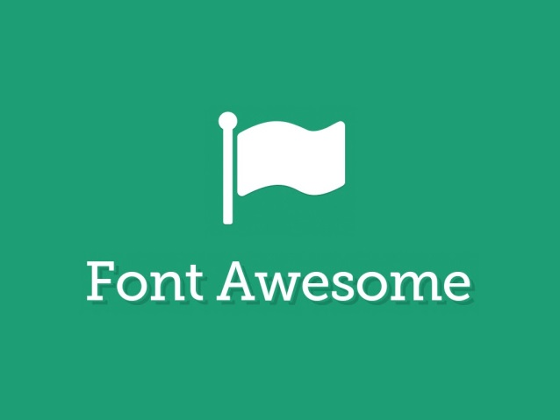 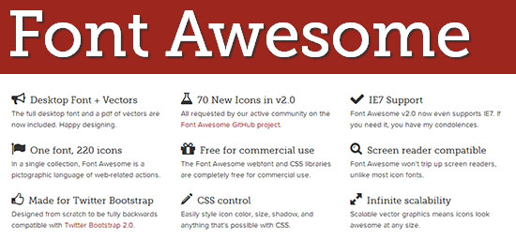

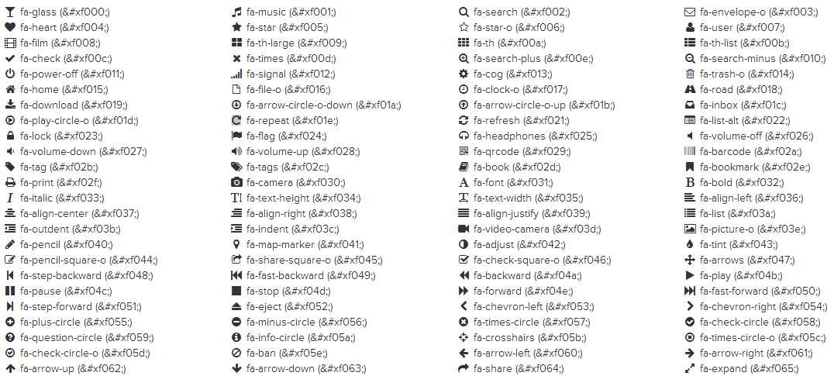

**4.Animate.css**

CSS has improved with many features which make web development much more interesting and challenging. One of these features is CSS3 animation effects. Before CSS3, to create an animation you can only work with Javascript. But now you can create it easily with CSS3.

We have walked you through with a good tutorial of creating Bounce Effect with CSS3 previously, and in this post I will introduce to you an awesome library that will make animation creation with CSS3 even easier: Animate.css.

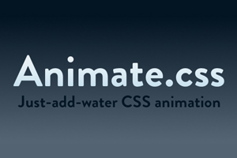 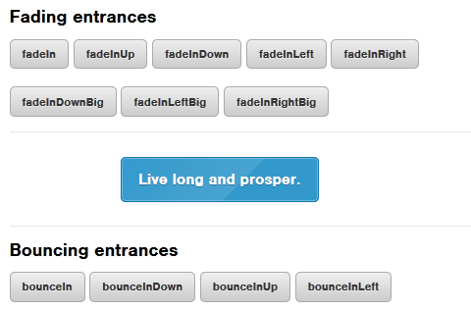

5. **WOW.js**

This module integrates the wow.js library into Drupal. WOW is a Javascript library which works nicely with the Animate CSS library to create great cross browser CSS3-based animations in your Drupal sites.

The Animate CSS library provides a complete set of CSS3 animations you can apply to any HTML element in your Drupal site using some JQuery code or providing some CSS classes on your templates for the HTML elements you want to animate. You can see this animations in action in the Animate CSS library's webpage.

The wow.js library provides more control over those animations, letting you to set how many times an animation will be repeated, how much time the animation will last, how much time the animation will delay until it will start, etc.

The wow.js library provides another nice feature: if you use the Animate CSS library only and you set an animation for an HTML element which is outside the fold, when you scroll down the page to see that HTML element, the CSS animation will probably have finished. Using the wow.js library with the Animate CSS library, the CSS animations of the HTML elements will start when those elements become visible as you scroll down the page. You can see a demo in the wow.js librarys's home page.

<script src="js/wow.min.js"></script>

<script>

new WOW().init();

</script

**2.3 GOOGLE API’s**

**Google maps**

After the success of reverse-engineered mashups such as chicagocrime.org and housingmaps.com, Google launched the Google Maps API in June 2005 to allow developers to integrate Google Maps into their websites. It is a free service, and currently does not contain ads, but Google states in their terms of use that they reserve the right to display ads in the future.

By using the Google Maps API, it is possible to embed Google Maps site into an external website, on to which site specific data can be overlaid. Although initially only a JavaScript API, the Maps API was expanded to include an API for Adobe Flash applications (but this has been deprecated), a service for retrieving static map images, and web services for performing geocoding, generating driving directions, and obtaining elevation profiles. Over 1,000,000web sites use the Google Maps API, making it the most heavily used web application development API.

The Google Maps API is free for commercial use, provided that the site on which it is being used is publicly accessible and does not charge for access, and is not generating more than 25 000 map accesses a day.Sites that do not meet these requirements can purchase the Google Maps API for Business.

The success of the Google Maps API has spawned a number of competing alternatives, including the HERE Maps API, Bing Maps Platform, Leaflet and OpenLayers via self-hosting. The Yahoo!

Maps API is in the process of being shut down.

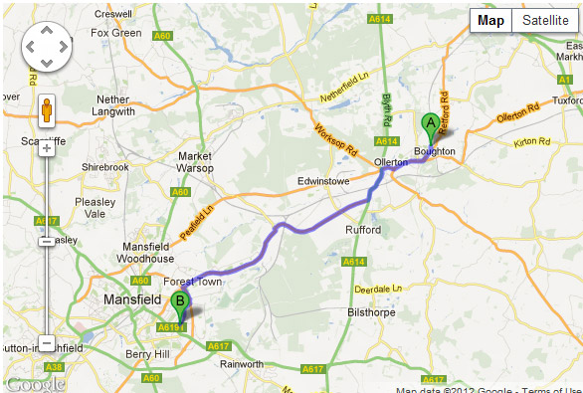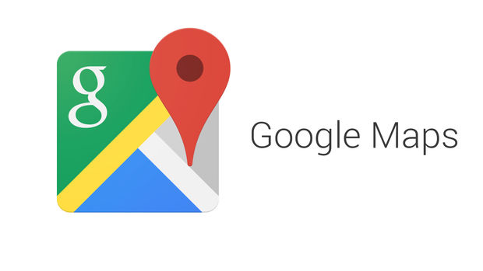

**Google fonts**

Google Fonts (previously called Google Web Fonts) is an interactive directory of free hosted application programming interfaces for web fonts. It was launched in 2010 and revamped in 2011.Many of the fonts are released under the SIL Open Font License 1.1, while some are released under the Apache License; both are free software licenses. The fonts are also served by Monotype’s SkyFonts and by Adobe’s Edge Web Fonts and Typekit services.

Google Fonts is designed to provide a platform for users to discover fonts and is used extensively. Its example font faces include Lato, Raleway, and Lobster.

Google refreshed the look and feel of their website in 2016.

There are over 800 fonts available via Google Fonts.

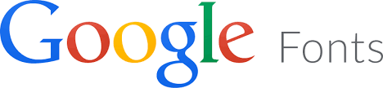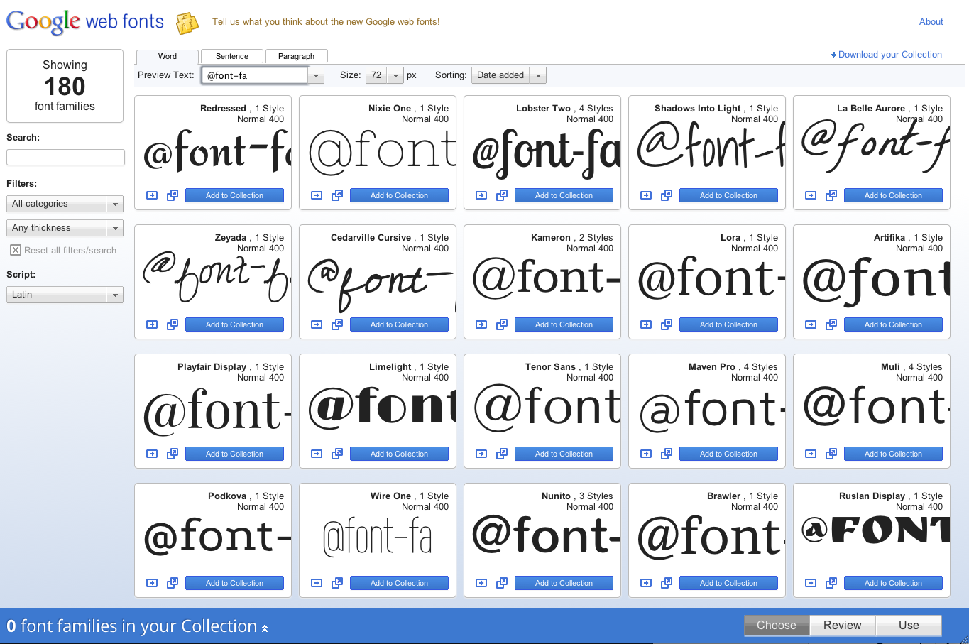

**CHAPTER 3**

**Screenshots**

1. Homepage

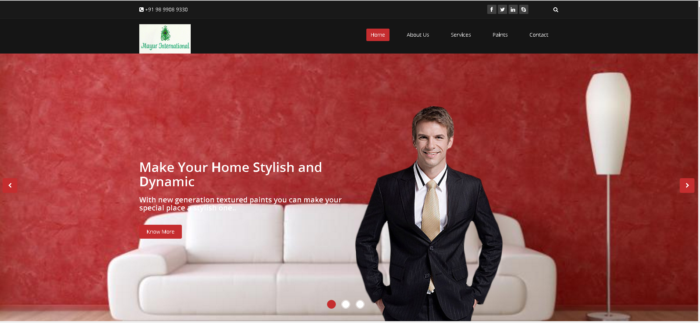

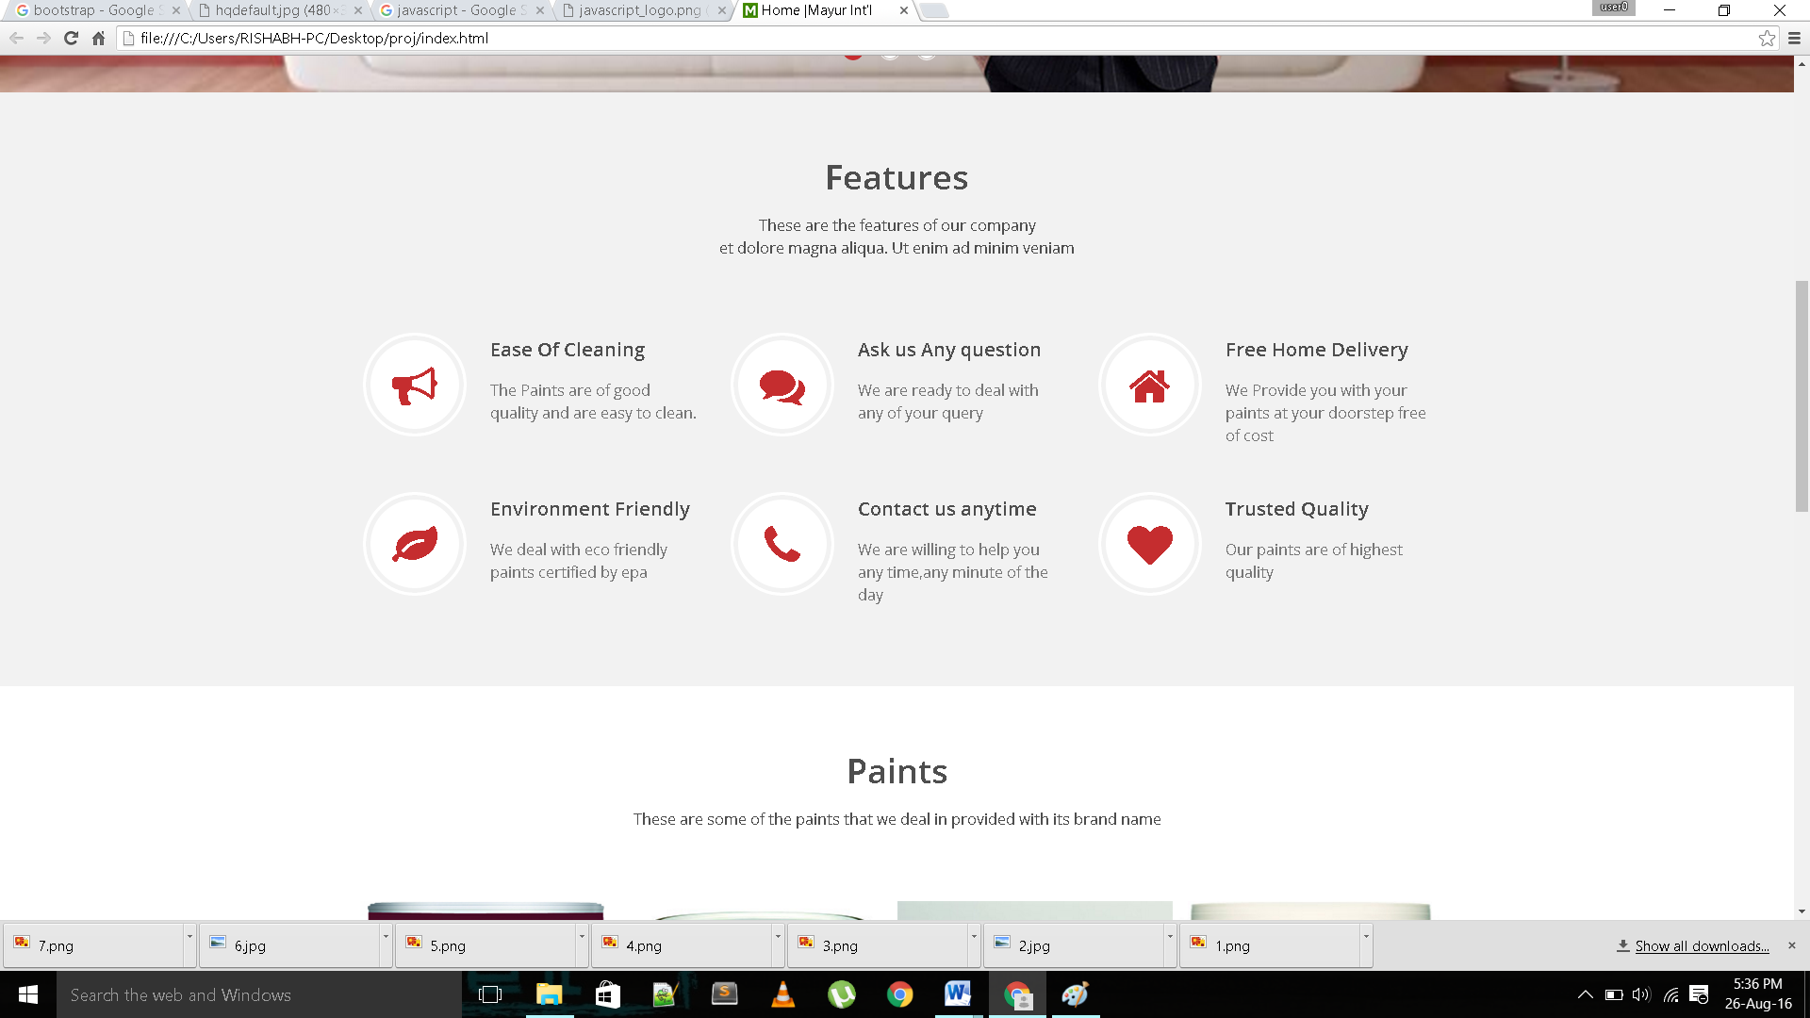

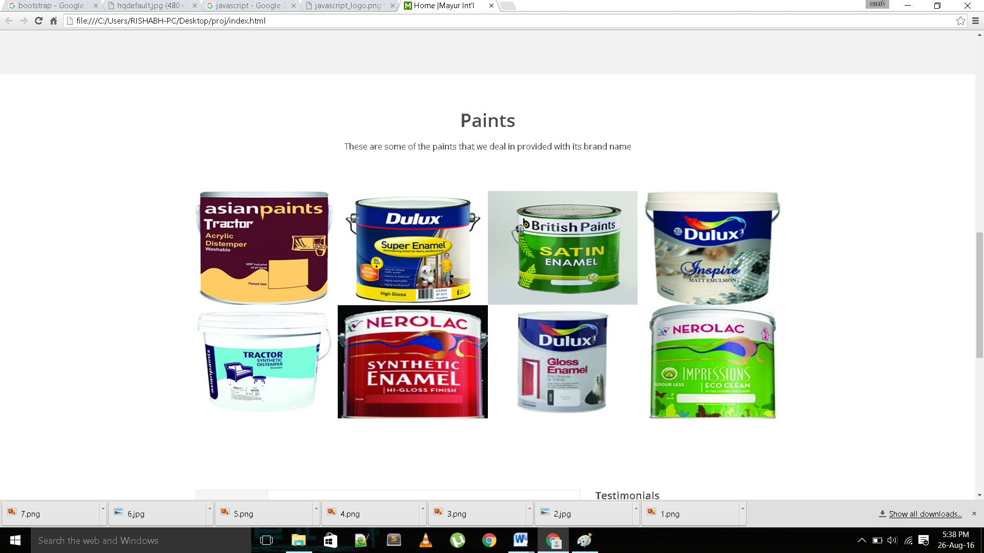

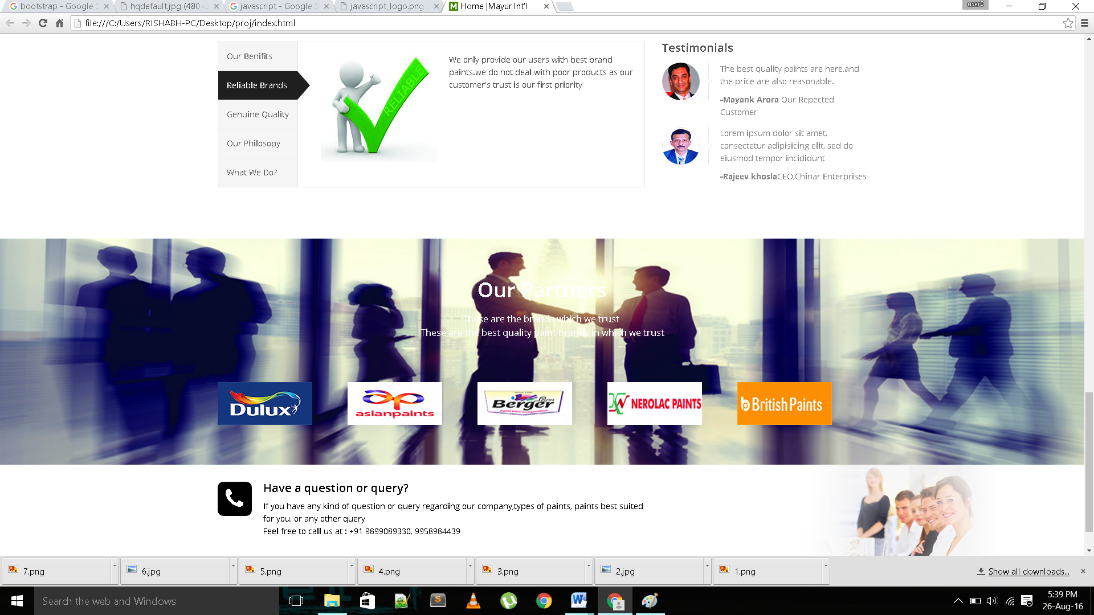

1. About us

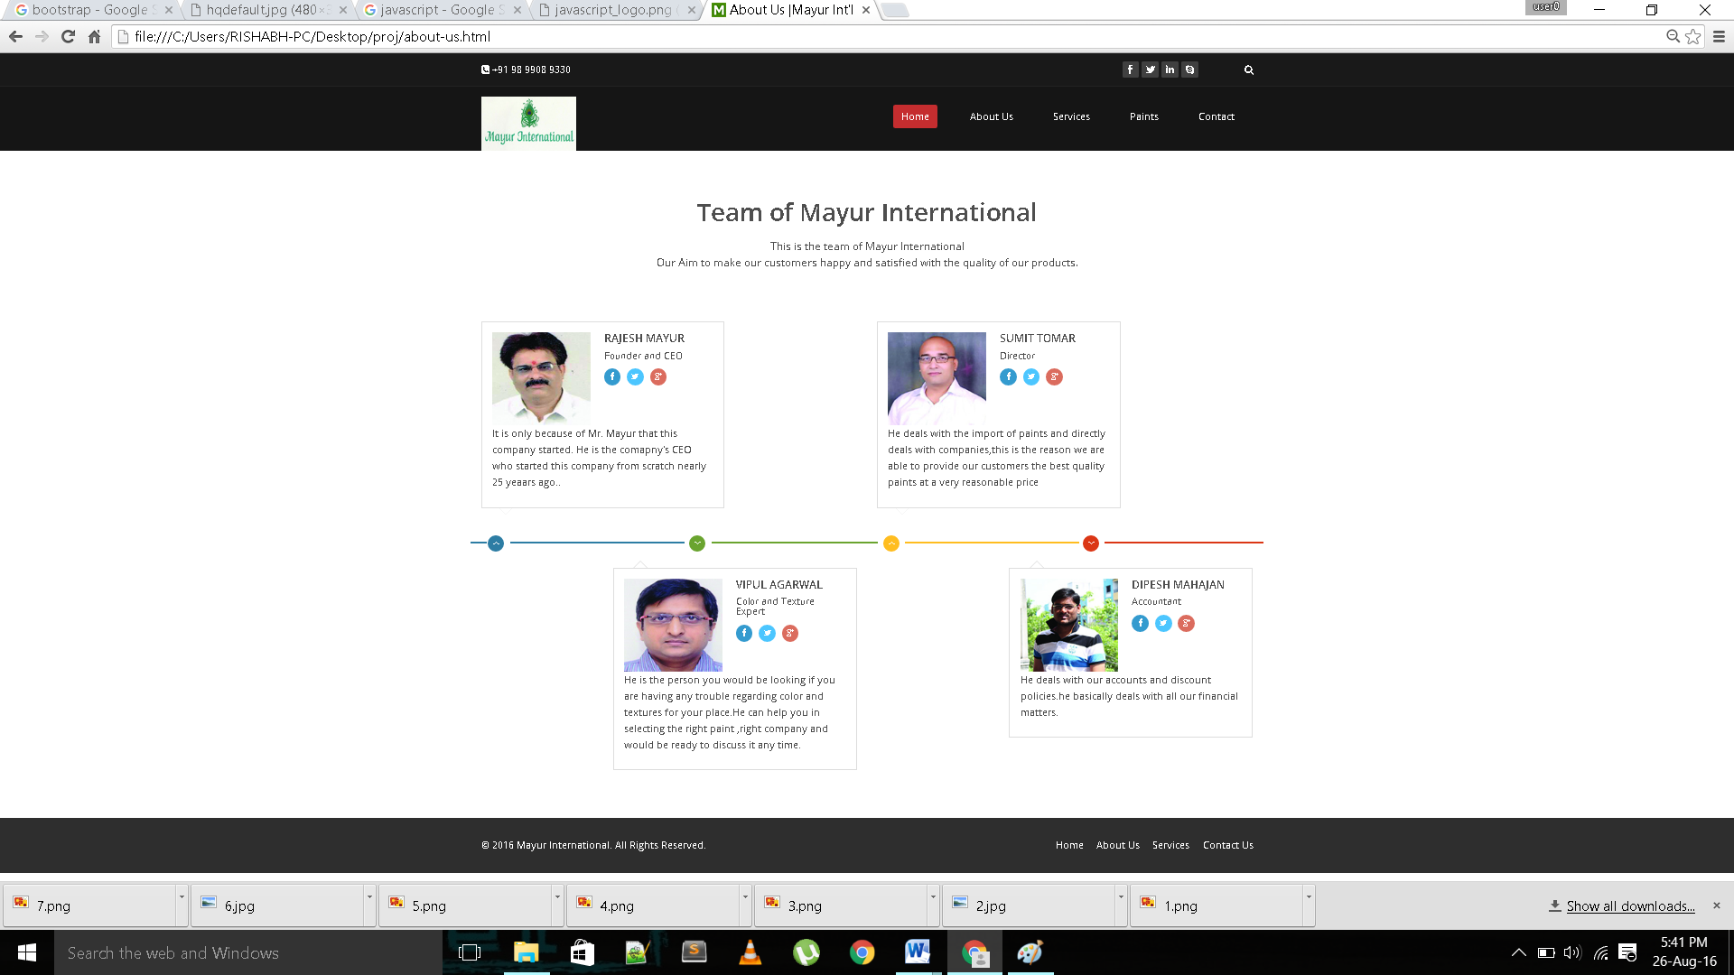

1. Services

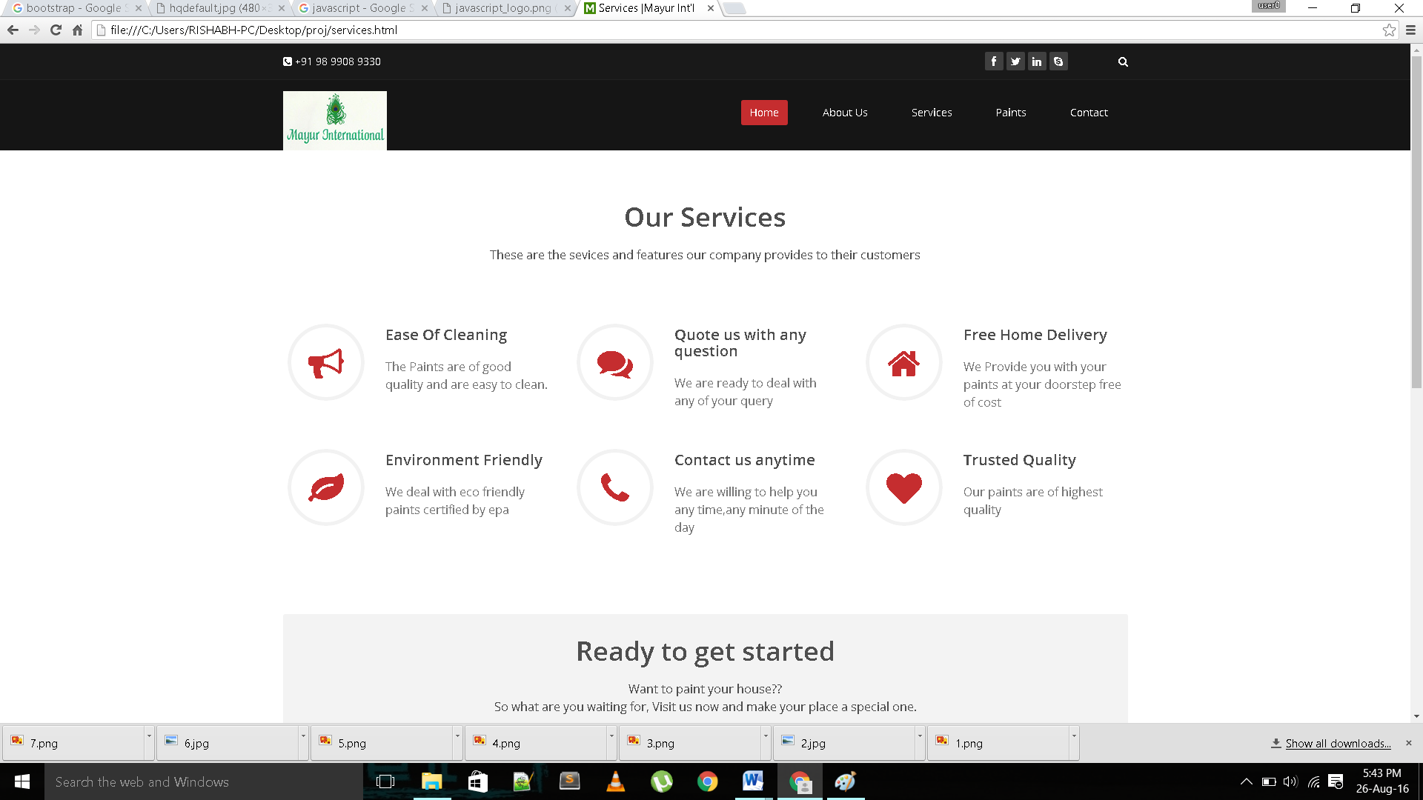

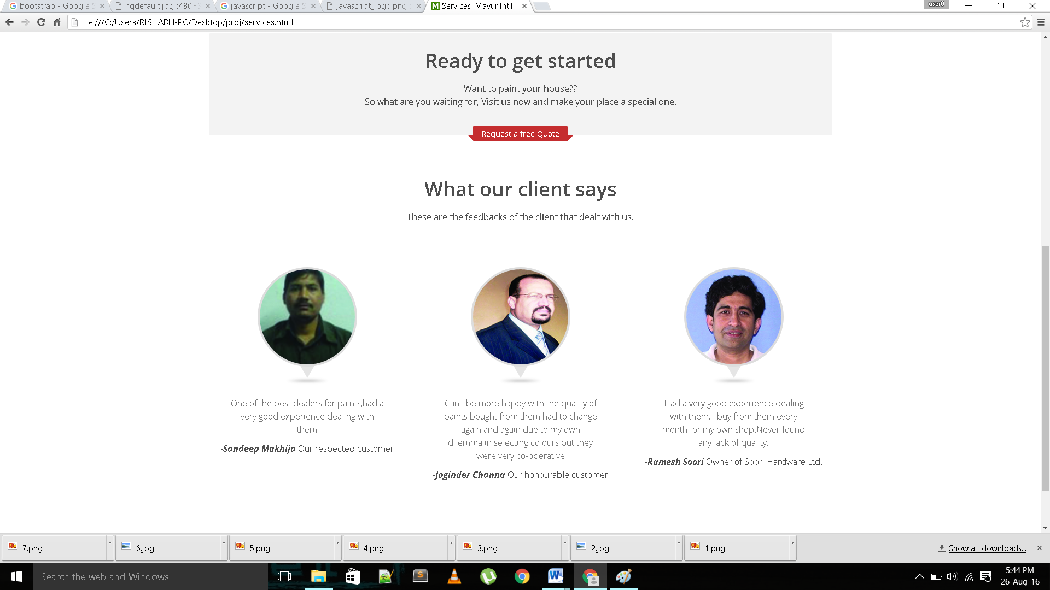

5.Paints

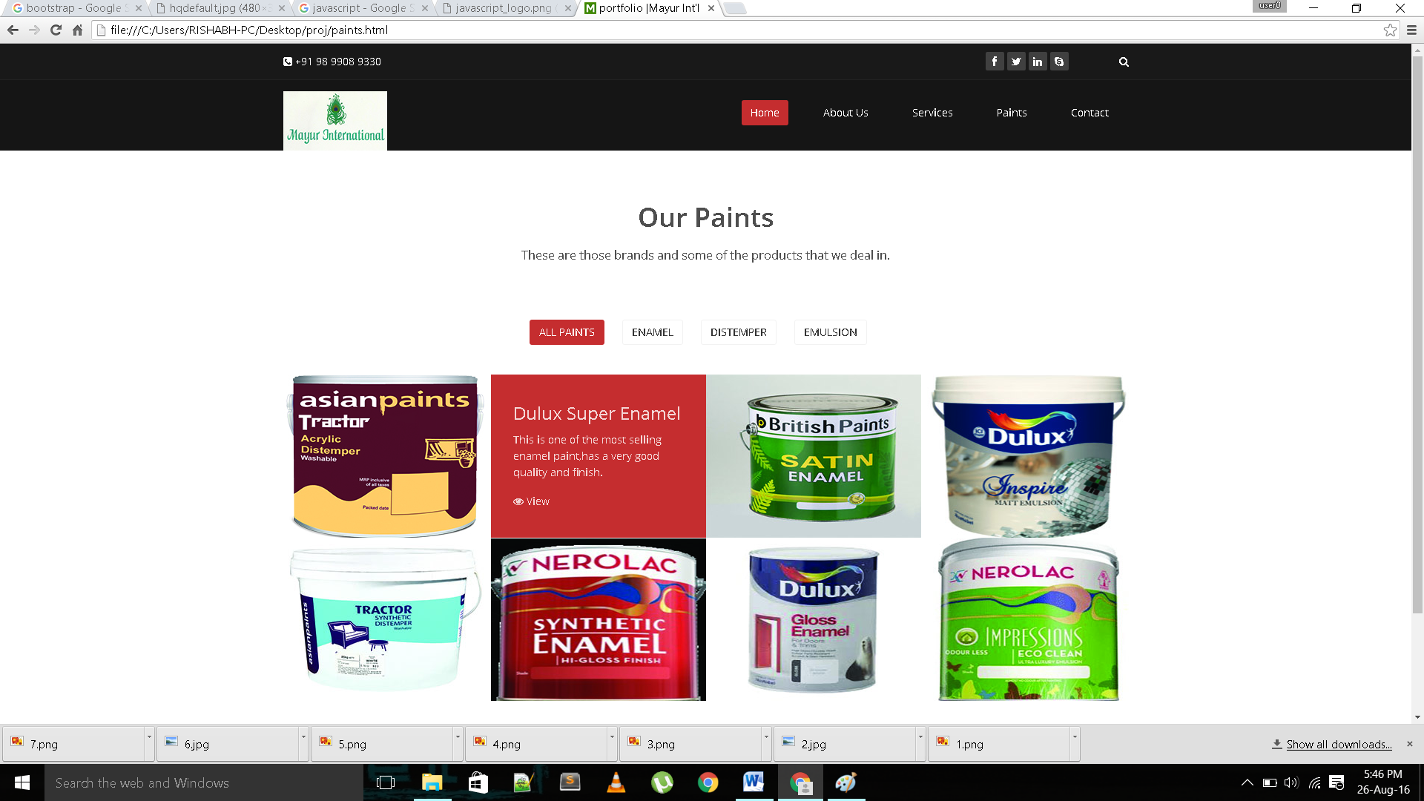

6. Contact Us

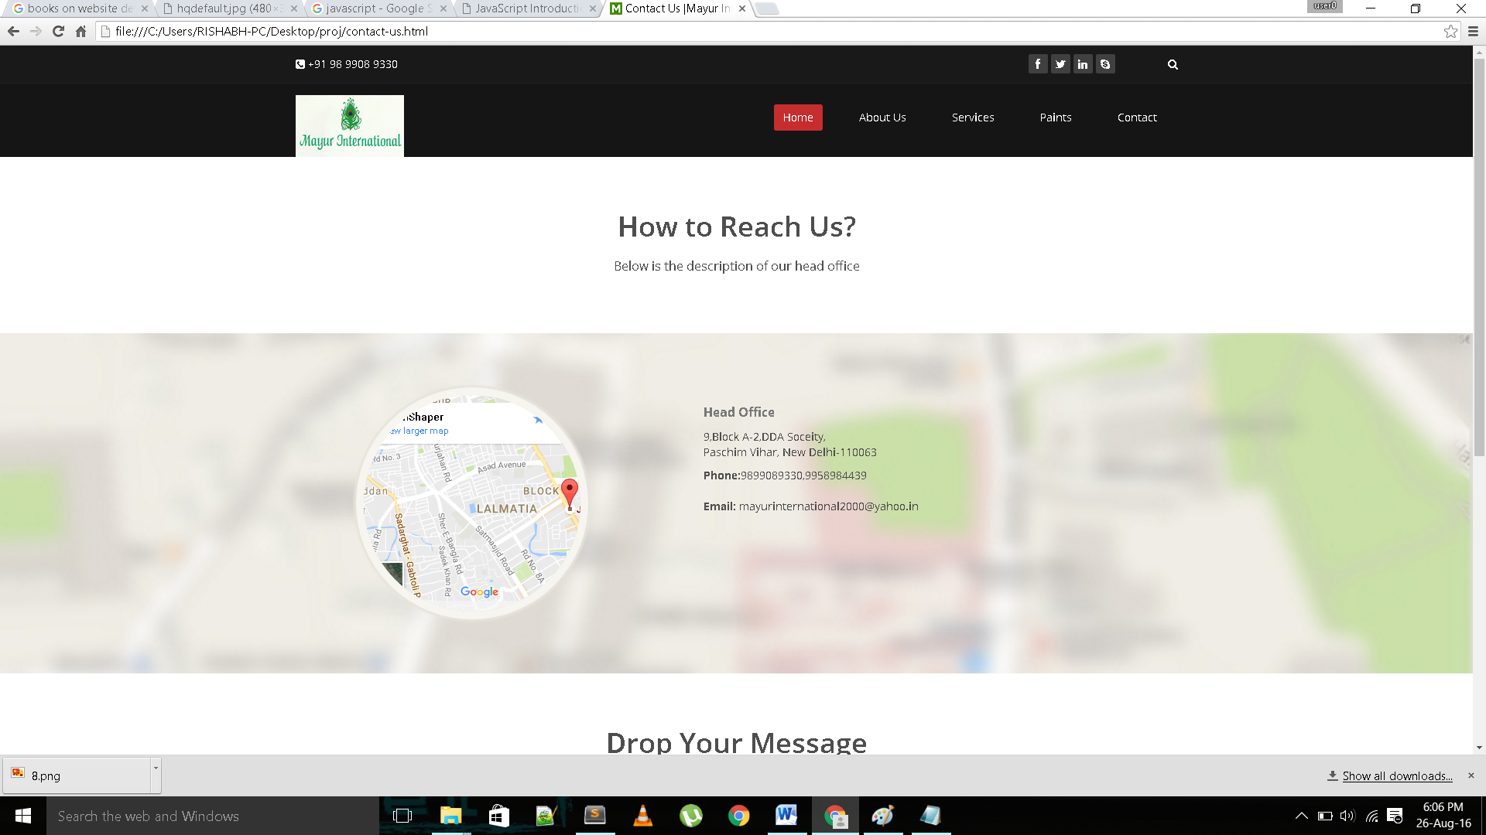

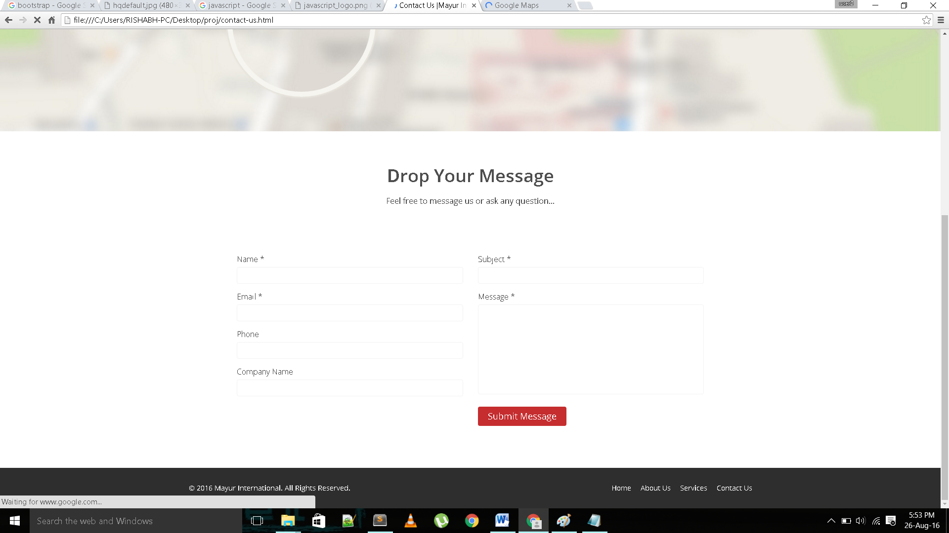

**Conclusion**

This website will help a user to know about the company’s vision and gives a brief about the product’s it deals with. If user visits this website he would given a brief about different paints that Mayur International deals with and would get to know about it’s employers and employees. This website uses html , css, javascript, jquery ,php , json, bootstrap and various other libraries and api’s for various purposes. It is a dynamic and responsive website that can be used at any platform and various screen types and dimensions. I have made an attempt to make it user friendly. There is an option in its contact us page that will help the user to quote a question or a query to the company and they will get a mail instantly that the company will answer to them soon.

**References/Bibliography**

* w3schools.com
* [tutorialspoint.com](http://www.tutorialspoint.com)
* github.com
* wikipedia.com
* Scalable and Modular Architecture for CSS book
* JavaScript & jQuery: The Missing Manual book
* HTML5 for Web Designers book
* Jqurey Novice to Ninja book